**### Submission Guidelines**

Provide the following:

- **\*\*Deliverable for Task 1:\*\*** Take a screenshot of all the GPOs created for this homework assignment. To find these, launch the Group Policy Management tool, select **\*\*Group Policy Objects\*\***, and take a screenshot of the GPOs you've created.

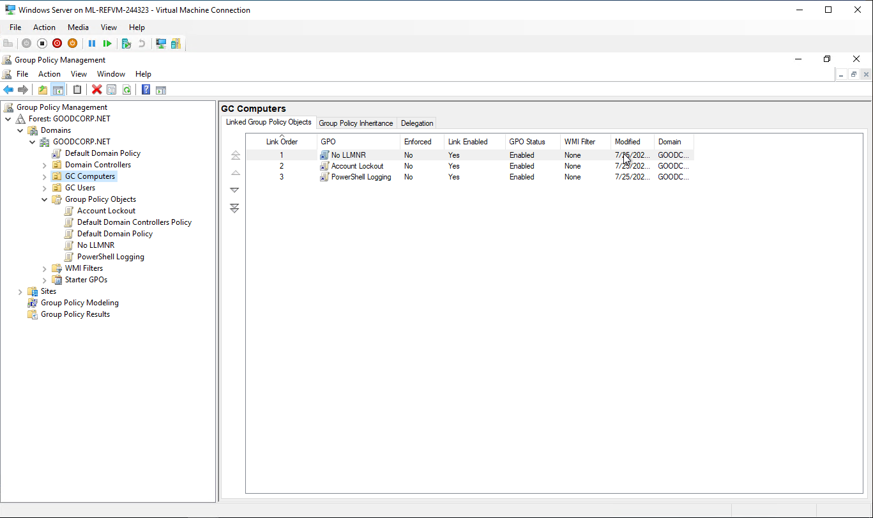

- **\*\*Deliverable for Task 2:\*\*** Submit a screenshot of the different `Account Lockout` policies in Group Policy Management Editor. It should show the three values you set under the Policy and Policy Setting columns.

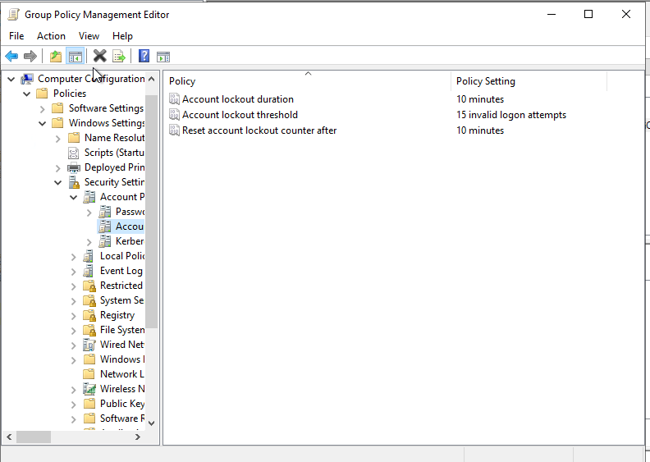

- **\*\*Deliverable for Task 3:\*\*** Submit a screenshot of the different `Windows PowerShell` policies within the Group Policy Management Editor. Four of these should be enabled.

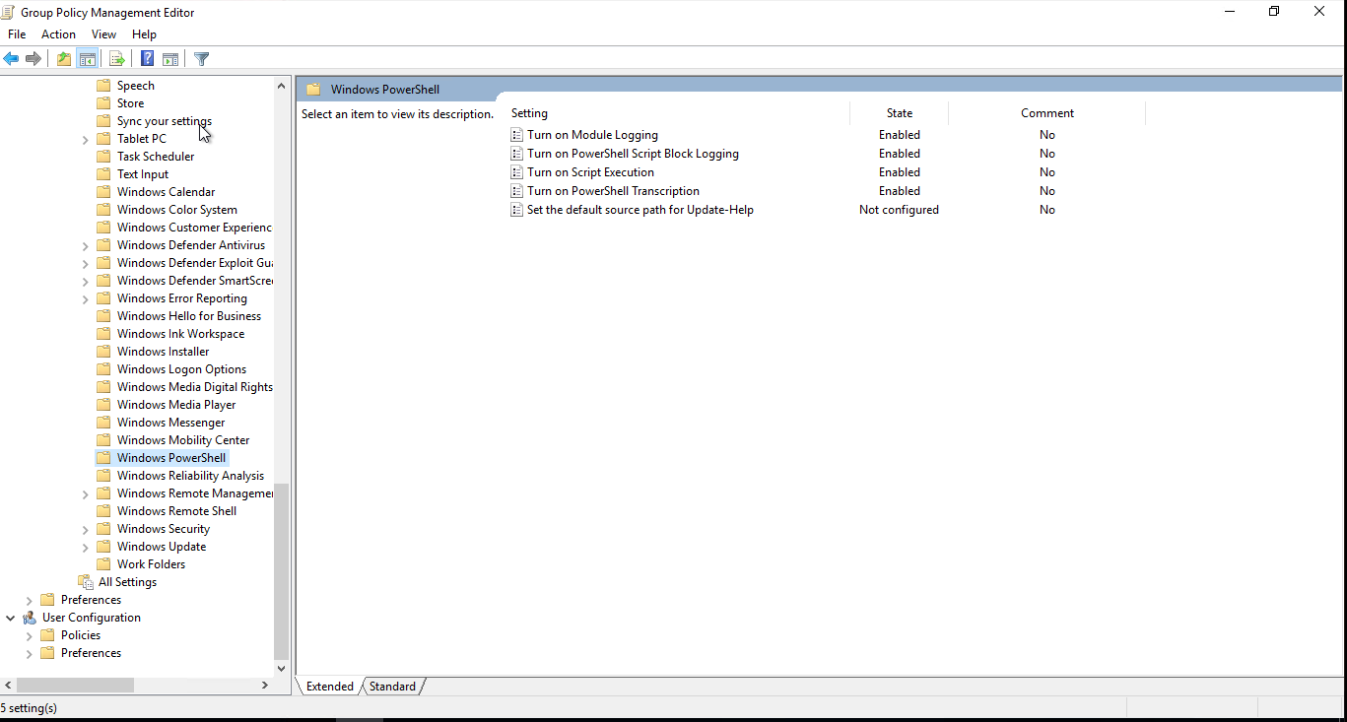

- **\*\*Deliverable for Task 4:\*\*** Submit a copy of your `enum_acls.ps1` script.

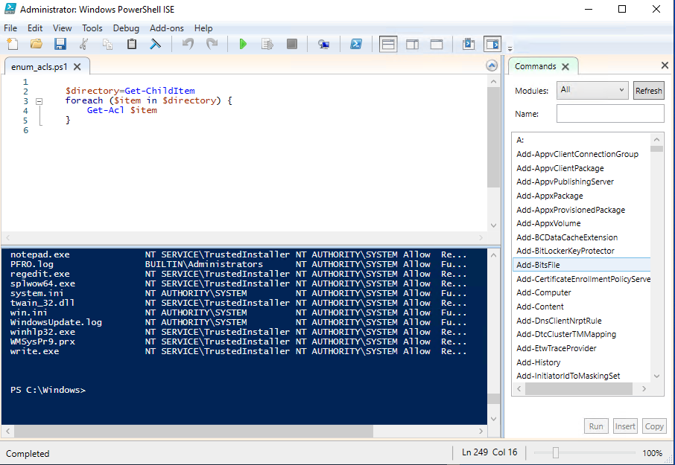

- **\*\*Deliverable for Bonus Task 5:\*\*** Submit a screenshot of the contents of one of your transcribed PowerShell logs or a copy of one of the logs.